a

ESOL
Cardiff & Vale College

Welcome Booklet 2024-2025
1 Canal Parade




Welcome!
We are happy to see you at Cardiff & Vale College, and hope you have an excellent time learning English with us this year.

We aim to put you, the learner, at the centre of what we do here and to include everyone in the learning experience.

You have enrolled on the ESOL course (English for Speakers of Other Languages). We want you to enjoy your studies, improve your English skills, and achieve a positive result by the end of year.

To do this, you need to know about the college, so this Induction booklet is a useful introduction to help you get started. It will help you to learn about the college, and what is expected from both students and teachers.

Good luck!



Cardiff & Vale College
CAVC is the largest college in Wales and in the top three largest colleges in the UK, with over 30,000 students. There are over 1500 learners studying ESOL.
There many great opportunities and support for you this year, and lots of options for you to continue your education here at CAVC after you finish your ESOL studies.
The ESOL leadership team:
Yusuf Ibrahim
Vice Principal

Judith Scanlon
Head of ESOL

Cathy Tong
Sophie Curien
Deputy Heads of ESOL

Carol Stewart & Laura Evans
Departmental Administrators
www.cavc.ac.uk

This Photo by Unknown Author is licensed under CC BY-ND
1 Canal Parade
You must wear your student ID card and lanyard at all times.
We share 1 Canal Parade with offices, so it is important that we take excellent care of it and act appropriately at all times. Let’s be respectful of everyone here and also the building itself.
Let’s be safe, keep it tidy and clean, take care when using computers and equipment, and be sure to follow the rules.

Floors & Classrooms

ESOL classes are all on the 2nd floor only at 1 Canal Parade.
The classrooms are new, with new tables, chairs and equipment. We mustn’t mark or write on any surfaces, nor leave any rubbish or gum anywhere. Let’s tidy up after ourselves. Don’t leave anything behind.
There are two IT rooms with computers.
All F/T students will be provided with a device to use in college and at home. If you do not have one please speak to your Tutor. Your Tutor may ask you to bring your device into college when you study face to face. There is also a printer/photocopier on the 2nd floor. Please be careful when using the computer equipment.

Toilets

Toilets for ladies, gentlemen and disabled are located on every floor. Student toilets are on the first floor. These are located opposite the lift.
We share them with professionals from the offices in the building too. So, we must be very clean and respectful!
Also, for health and safety, be sure to wash your hands with soap and dry them upon every visit to the toilets!

Lifts & Stairs

There are three lifts and one set of stairs that we share with all the other people who work in the building.
Success Centre

The Success Centre is in the main City Centre Campus. It is a library with books and computers. There are also printers/ photocopiers you can use. You should visit the Success Centre every week to support your learning. It is on the 2nd and 3rd floors, open Monday to Thursday from 8:30 - 5pm and Friday 8:30 - 4pm.
You can take books home by checking them out at the desk using your student card. Please bring them back on time or ask at the desk to borrow them for longer. You can also ask the librarians to reset your password if you forget it when logging onto the computers.
You are also able to borrow books using the online click and collect service.
You can reserve books by clicking here or visiting the link below:

https://heritage.cavc.ac.uk/

Alternatively, speak to a member of the team if you want to reserve a book whilst on site. All students can access e-books and online resources through the student portal. If you want to book a computer or study area you need to email the following address: successcentre@cavc.ac.uk

Skills Centre
In the success centre, you also can get extra help with your English, Numeracy and Computer skills.
The Success Centre can offer ESOL students the following:

- Access to books for their course and for general interest.
- Students can join in our reading scheme ‘Reading Ahead’.
- Staff can help students access online resources such as eBooks, journals, searching the library catalogue
- Help with printing/photocopying
- Help with accessing their student emails, course modules on Moodle, checking attendance etc.
- Staff can also provide help with IT skills in Word, PowerPoint etc.
- The Skills Centre can provide support for English, maths and IT
- Opportunities to improve their speaking and listening and meet other students with our ‘Talk Tidy’ conversation club
If you would like extra help or support, you need to ask your tutor to arrange this for you. This can be a one-off session or on a weekly basis. Contact: learningcoach@cavc.ac.uk
You are advised to visit the Study and Skills Centre regularly to support your studies. Your Tutor will be informed when you go, so please be sure to visit often!

Student Services



The Student Services team are located in the Success Centre (2nd floor) in the main City Centre campus. Ask at the front desk and they can direct you. Student Services can help you with general course or college queries and issue you with forms that you may need to apply for student finance. Please ask your tutor for any letters you may need, before going to Student Services.

Health & Safety

You are responsible for your own health and safety whilst at college and during any class trips.
Please be considerate and follow the rules at all times. If you are a returning student, take care to cooperate with any new rule changes.
If you have any medical problems, allergies or conditions, you must tell your Tutor.
If you see anything unsafe or inappropriate, please report it to a member of staff immediately.

Health and safety includes:
Fire Procedures

All classrooms have a sign saying what to do if there is a fire. Please read this carefully and speak to your tutor if you need more help.
There may be a Fire Drill to practise leaving the building in a safe manner if there is ever an emergency.
The lift must not be used in the event of a fire alarm.
If you have difficulty with going up or down stairs, please talk to your Tutor to help plan what to do in case of a fire.

Eating & Drinking


Please note: eating and drinking are not permitted in the classrooms or corridors, except for water only.
Water is not permitted in classrooms when at the computers.
Food and drinks are available at the café and shop in the main building.
Please let your Tutor know if you have any food allergies, intolerances or preferences, as there may be times when food and drinks are served to students at college.

Keep It Tidy


Please put your rubbish in the bin. Use the bins in the Ground floor foyer.
Classrooms bins are for recycling waste only (paper, plastic bottles). Please do not put any other kinds of waste in the classroom bins, but use the foyer bins instead. Chewing gum is not permitted in the classrooms. It should not be chewed during class at any time. It should be put into a foyer bin.
No Smoking


Smoking is not permitted anywhere on campus. This includes e-cigarettes.

Prayer Room

There is a Prayer Room for use by people of all faiths next door in the City Centre Campus.
It is down the hall on the left behind the café (near the salon).
There are washing facilities for use.
Please check with your Tutor about access or ask at Reception.

Extra measures to keep us safe
On campus
- Sanitise hands on arrival at any campus and wash them regularly.
- Do not move furniture (chairs, tables) in your classrooms.
- Do not smoke or vape anywhere on campus

College signs- these are the college signs you will see around campus. Please take time to read these.

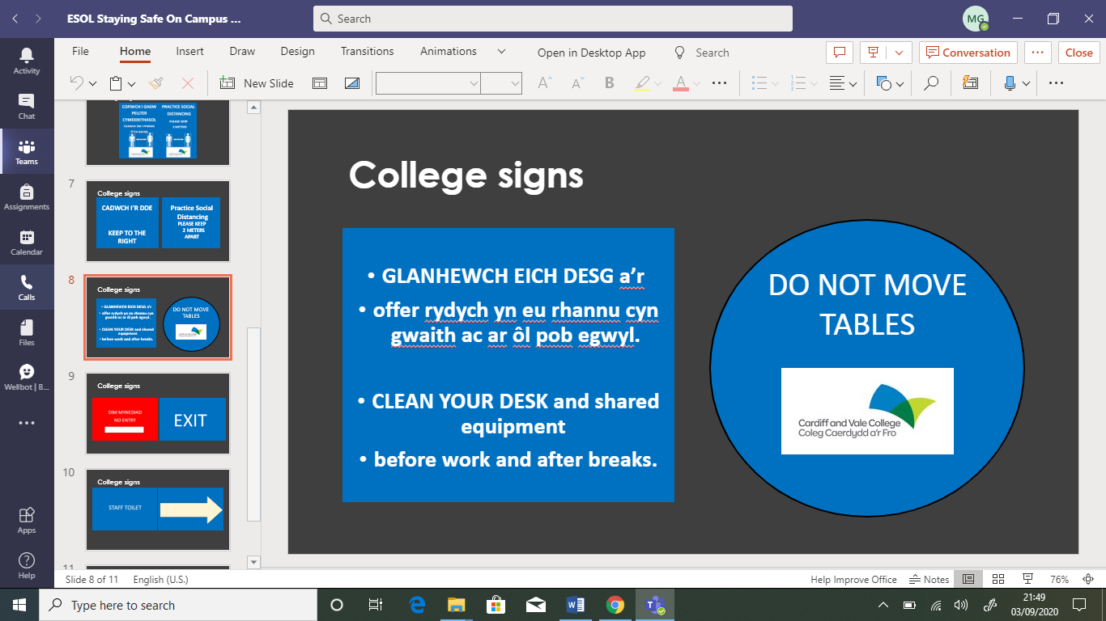

Learner Agreement
This year we are using Microsoft Forms for the learner agreement. Your teacher will send you a form. Read this carefully first, complete the information required and then click to agree.
Learner agreement Microsoft Form

ESOL ENROLMENT AGREEMENT

Name
Date of Birth
ID Number
Course

Before you study ESOL, you must agree to:
- ATTENDANCE
You should have 100% attendance.
This includes face to face classes in college, online sessions and independent study.
If you cannot come to college or attend your online session, you must tell your teacher before the start of class.
You must bring proof of all authorised absences (please see overleaf).
You will have a meeting with a teacher if within a given month your attendance falls below 90% for full-time students or 87% for part-time students.

- PUNCTUALITY
You will arrive on time for the start of all classes.
If you are more than 10 minutes late, you cannot join the class and will have to wait until the next session.

- HOMEWORK & INDEPENDENT STUDY
You should study independently for approximately 10-12 hours per week (full-time students) or 4-8 hours per week (part-time students).

- PART-TIME EMPLOYMENT
Work hours should not be at the same time as your class timetable.

- EXAMS & EXPECTATIONS
All students should achieve the qualification attached to their course.
Exam entry is not guaranteed and neither is progression. Exam entry and progression will depend on progress tests, exam results, homework submission and attendance. Your teacher will decide if you are ready to take your exams. This is the final decision.

Exams may take place within two weeks of the course end date.
Students on full-time courses are expected to progress from one level to the next within a year. Students on part-time courses are expected to progress over two years.

- PHONES
Phones must be switched off during class time.
3

- PROGRESS WEEK

All students must successfully complete the first half-term, including Progress Week, to stay on the course.

SIGNED:____________________________________ DATE: _______________


Student Absences

Attendance at college is a legal matter so we must keep accurate records that are reported to the Welsh government. There is a strict policy for student absences.
You signed the ‘Learner Agreement’ that says you should have 100% attendance.
If you are going to be absent from class, you must tell your Tutor as soon as possible before the date of absence. It is very easy to report your absence through the CAVC App. Download the App and on the home page you will see an option to report absence. Type in the date you are going to be absent.
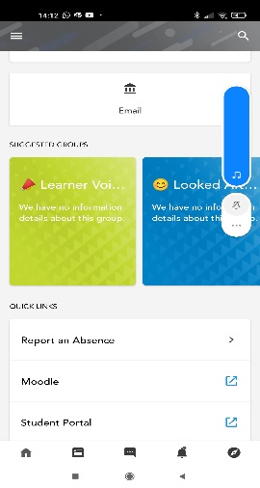
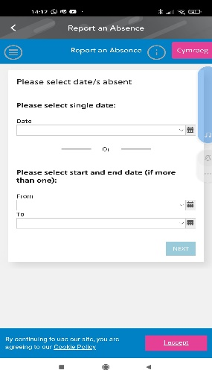

You can also use the following methods to report absence.
- Phone the college: 02920 250 263
Leave a clear, detailed message:

Hello, my name is ___________, and my student number is ___________. My class course code is ___________, and my teacher’s name is___________. I will be late/cannot come in today because _________________________________.

- Write your class teacher an email or Teams message before the lesson.
Please see the rules for which kinds of absence can be authorised, and which kinds cannot. It is important to know that this year student progression will be based on your overall attendance, your percentage of classes attended. Both unauthorised and authorised absences will be counted against this.
Authorised absences must be approved one week before the lesson, and proof must be shown to your Tutor (i.e. appointment letter).
Please note: absence due to sickness is not authorised.
You may receive a text message from college if you are unexpectedly absent.

CAVC Calendar 2024-2025

Term | Activity | Starts | Ends
Autumn 2024 | Induction week | 2nd September | 6th September
 | Autumn term | 2nd September | 20th December
 | Half-term | 28th October | 3rd November
 | Christmas break- college closed | 21st December | 5th January
Spring Term 2025 | Spring term | 6th January | 10th April
 | Half-term | 24th February | 28th February
 | Easter break | 14th April | 25th April
Summer Term 2025 | Summer term | 28th April | 20th June
 | Half-term | 26th May | 30th May

Reminder



As stated in the Learner Agreement, your teacher will carefully monitor you for the first half-term.
This means that your tutor and class teachers are watching carefully to see you are following the college rules, especially those set out in the Learner Agreement.
Take care to attend every class both in college and online, be punctual, do all your homework and independent study, switch off your mobile phone during class, be respectful to others, and make a sincere effort to do your best.



… and enjoy your studies!

